3D tutorials

These tutorials are meant for people who know a bit of Python and 3D. As you will see, Spyder has strong support for Python scripting of 3D objects: it contains its own (pre)viewer and it provides a very quick way to create Blender plugins for editable objects.
You must have Spyder installed with the modules “blender”, “tarantula” and “models3d”.

Tutorial 1: Creating parametric objects with Python, using Spyder

A. Creating a simple block
It is very easy to create Spyder 3D objects in Python. For example, open IDLE or a Python command prompt and type:

>>> import Spyder
>>> Spyder.init()
>>> from Spyder import *

This will import all classes and modules that are provided by Spyder. Many of them are 3D-related, for example Block3D.

>>> Block3D((3,3,3)).show()

Now a 3D grey cube should appear, within a window called "Tarantula 3D viewer". Tarantula is the 3D part of Spyder, and contains its own (pre)viewer.
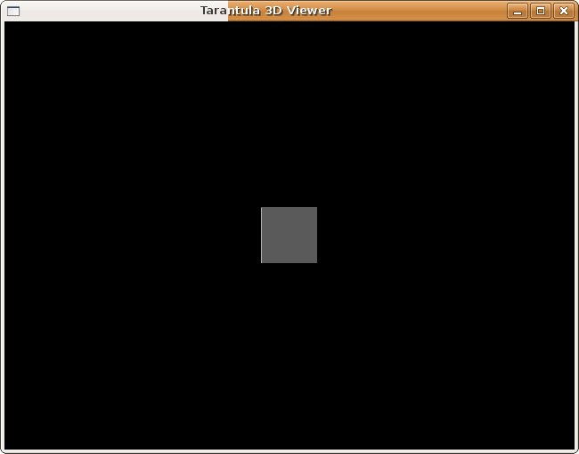
You can view the box from different angles using the arrow and numpad keys, combined with SHIFT, CTRL and ALT.

With the following commands, you can clear the previewer and create another block, slightly larger this time:

>>> tarantula.clear()
>>> Block3D((5,5,5)).show()

If you want to kill the previewer window, press Esc. However, this will cause the interactive Python shell to terminate. IDLE will automatically restart it for you, but you will have to type the first three lines again. On Linux, you will have to restart your complete shell. Therefore, let’s move on to putting our commands in a script. Press Esc anyway, and then create a new Python file called “test.py”, containing the previous commands:

import Spyder
Spyder.init()
from Spyder import *
Block3D((3,3,3)).show()

Save it, and run it. Now we have our block again. Pressing Esc will terminate the script normally now. You can play with it, changing the shape of the block, add a second block, or specify several blocks with a for loop.

Now let’s run the script inside Blender. This requires that we initialize Spyder with the BLENDER switch. So change the second line of test.py:

Spyder.init(“BLENDER”)

and save.
If you are on Linux or on a Mac, start Blender from the terminal as blender –P test.py. If you are on Windows, start Blender, go to Text Editor => Text => Open => “test.py”, then press Alt+P.
You will see our grey cube appear inside the Blender 3D window. Click on it, and select Object => Script => Create/edit Spyder object (make your 3D window a bit larger if you cannot the Script menu entry). As you can see, you can edit the parameters of the Block3D inside Blender! See the tutorial about editing Spyder objects in Blender for more details.

But now the script has become dependent on Blender, it will not run in the previewer anymore. With the following code, we make the BLENDER switch conditional, depending on the presence of the bpy module (which is only available inside Blender):

import Spyder
try:
import bpy
switches = “BLENDER”
except ImportError:
switches = None
Spyder.init(switches)
from Spyder import *

Block3D((3,3,3)).show()

You can verify that it works both inside and outside Blender.

Spyder web files are also a good intermediate between Python and Blender. Remove the last line and write:

b = Block3D((3,3,3))
b.tofile(“test.web”)

When you open test.web with a text editor, you will see that it is actually a very verbose description of a Block3D object.
Web files can be opened in Blender with Import => Spyder file, or with the Spyder manager, and exported in the same way. In Python, they can be loaded with the fromfile() class method:

b = Block3D.fromfile(“test.web”)

So you can create parametric objects by script, write them to file, edit them in Blender, and load them back in a script!

B. Diving deeper into parametric objects

There are many parametric object classes in Spyder, and every class is built differently. Now we will learn to read Spyder class definitions, so that we can find out how they work and how they can be created from script.

First, back to the interactive Python interpreter. Since we just killed it, restart it and type again the commands we typed before. Every Spyder type has a help() method that gives information on how it works.

>>>Block3D.help() #NOT help(Block3D)!!

Help on class Block3D in module __builtin__:

class Block3D(object)
| Spyder-generated class
|
| module tarantula
| file /home/sjoerd/Spyder/tarantula/Tarantula.spy
|
| Class for rectangular blocks
|
|---------------------------------------------------------------
| Spyder definition:
|
| Coordinate dimensions
| Material material = "defaultmaterial"
| AxisSystem axis = AxisSystem()
| Enum pivot("center", "corner") = "center"
| def three_dimensional(): return True
|
|---------------------------------------------------------------
|
| Methods defined here:

....

Have a look at the Spyder definition. Every line starts with two words, the first word capitalized, the second word not. These are the attributes (or parameters) of the Block3D class. The second word is the name of an attribute, while the first word is its Spyder class. Spyder classes consist of other Spyder classes. In the case of Block3D, every Block3D object consists of a Coordinate object called dimensions, a Material called material, an AxisSystem called axis, and an Enum called pivot. The last three have an "=" in their declaration, meaning that they have default values. Therefore, the first parameter, dimensions, is the only one that really has to be specified. Let's have a closer look:

>>> b = Block3D((3,3,3))
>>> print b.dimensions
Coordinate (
x = 3.0,
y = 3.0,
z = 3.0,
)

As you can see, b.dimensions is a Coordinate object, consisting of three values x, y and z. Typing "Coordinate.help()" or "help(b.dimensions)" reveals that x, y and z are objects of the Float class, and "Float.help()" shows that Float is just a Python float with some extras.

Now, as you might have guessed from the output above, the print-out (or str conversion) of a Coordinate object is also a pretty-looking way to create a Coordinate object:

>>> c = eval(str(b.dimensions))
>>> print c

Clearly, there is more than one way to create a Spyder object. In fact, the statements below are all equivalent:

>>> c = Coordinate(x=1,y=2,z=3)

>>> c = Coordinate(1,2,3)

>>> c = Coordinate([1,2,3])

>>> c = Coordinate({'x':1,'y':2,'z':3})

>>> c0 = Coordinate(x=1,y=2,z=3)
>>> c = Coordinate(c0)

And therefore, this is valid, too:

>>> b = Block3D(Coordinate(1,2,3))

>>> c = Coordinate(1,2,3)
>>> b = Block3D(c)

>>> c = Coordinate({'x':1,'y':2,'z':3})
>>> b = Block3D(dimensions=c)

But, this works just as well:

>>> b = Block3D((1,2,3))

>>> b = Block3D(dimensions={'x':1,'y':2,'z':3})

Therefore, when you create a Block3D, the dimensions parameter doesn't have to be a Coordinate, as long as a Coordinate can be constructed out of it.

Finally, all Spyder classes can also parse strings, including their own print-outs:

>>> c = Coordinate("[1,2,3]")

>>> c0 = Coordinate(x=1,y=2,z=3)
>>> c = Coordinate(str(c0))

>>> b = Block3D(dimensions="[1,2,3]")

>>> b = Block3D("Block3D([1,2,3])")

As you might have guessed, the print-out of a Spyder object is exactly what is written in a web file. Don’t worry about security, the eval() function is never used by Spyder to parse strings or files.

Right now you may be bored of all these Coordinates and Block3Ds, but it all sums up to this: You can construct Spyder objects pretty much any way you want.
And that saves you time. And it makes your code look nice and clean.

TIP: You might prefer to access the Spyder type definitions and documentation in HTML format, with clickable hyperlinks. Look at http://www.spyderware.nl/doc/Block3D for Block3D, and on http://www.spyderware.nl/doc for an overview of all classes.

Now let's have a look a more interesting 3D object, and see if we can figure out how it works:

>>> Tube3D.help()
Help on class Tube3D in module __builtin__:

class Tube3D(object)
| Spyder-generated class
|
| module 3dmodels
| file /home/sjoerd/Spyder/3dmodels/tube.spy
|
| 3D object class for a hollow tube
| The tube is oriented along the X axis
|
|
|--------------------------------------------------------------
| Spyder definition:
|
| Float innersize
| Float outersize
| Integer radialsegments
| Float length
| Integer lengthsegments = 1
| Material material = "defaultmaterial"
| AxisSystem axis = AxisSystem()
| validate {
| assert(innersize > 0)
| assert(innersize < outersize)
| assert radialsegments >= 3
| }
| form {
| BLENDER

...

What do we have here? Three required parameters, and three default ones. The last two default parameters are axis and material which we encountered before, but didn't use. After that comes something between {} that is called validate and that seems to describe limits and rules for the parameters. Finally there is a similar {} block with Blender formatting instructions, but let's ignore that for now.

Let's give it a go:

>>> t = Tube3D(innersize=3, outersize=5, radialsegments=64, length=10)
>>> print t

That works fine. Now let's see how it looks. Switch to "test.py", delete the Block3D code and type this:

Tube3D(3,5,64,10).show()

Save and run “test.py” and now you can see a nice tube:
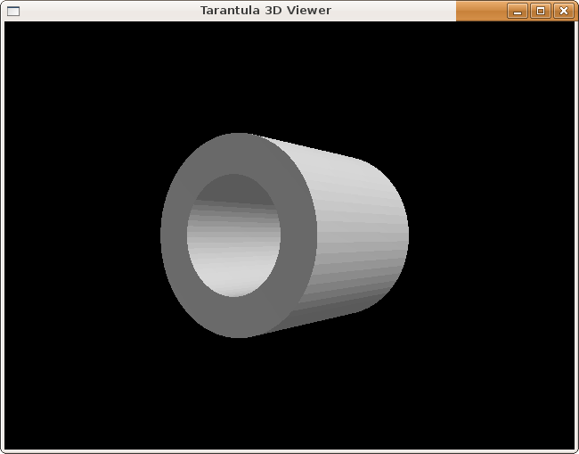
Now let's have a look at the validate block. It contains a set of Python assert statements, and it will raise an error if any of these are violated:

>>> t = Tube3D(innersize=10, outersize=5, radialsegments=64, length=10)

Traceback (most recent call last):

File "<stdin>", line 1, in <module>

File "/home/sjoerd/Spyder/temp/default/3dmodels/tube_spy.py", line 207, in __init__

self.validate()

File "/home/sjoerd/Spyder/temp/default/3dmodels/tube_spy.py", line 314, in validate

self.__validate__()

File "/home/sjoerd/Spyder/temp/default/3dmodels/tube_spy.py", line 333, in __validate__

assert(innersize < outersize)

AssertionError

Which makes sense: a tube should not be bigger on the inside than on the outside.

And now, let's have a look at the default parameters. We have lengthsegments, which is pretty straightforward. Increasing it will cut the tube into pieces, although their borders are hardly visible in the previewer.

material is a bit special. For all purposes, this parameter functions as a string. In "test.py":

Tube3D(3,5,64,10,material="defaultmaterial").show()

will work just fine. However, if you change "defaultmaterial" to something else, it will not work:

Tube3D(3,5,64,10,material="red").show()

AttributeError: 'NoneType' object has no attribute 'color'

If you want to make your tube red, you should do it like this:

NewMaterial(name="red", color = Color(r = 255, g = 0, b = 0)).show()
Tube3D(3,5,64,10,material="red").show()

or, somewhat shorter:

NewMaterial("red", (255,0,0)).show()
Tube3D(3,5,64,10,material="red").show()

You have now defined the material "red" (with RGB values (255,0,0)) and you can use it in any object you wish.

The last parameter, axis, defines the position and rotation of your object. It is an AxisSystem object, consisting of four Coordinates:

|------------------------------------------------------------------
| Spyder definition:
|
| Coordinate origin = (0,0,0)
| Coordinate x = (1,0,0)
| Coordinate y = (0,1,0)
| Coordinate z = (0,0,1)

...

All four coordinates have default values, so that you can construct an AxisSystem without specifiying anything:

>>> a = AxisSystem()
>>> print a
AxisSystem (
origin = Coordinate (
x = 0.0,
y = 0.0,
z = 0.0,
),
x = Coordinate (
x = 1.0,
y = 0.0,
z = 0.0,
),
y = Coordinate (
x = 0.0,
y = 1.0,
z = 0.0,
),
z = Coordinate (
x = 0.0,
y = 0.0,
z = 1.0,
),
)

which is the identity matrix.

The Coordinate and AxisSystem classes are equivalent to 3D coordinates/vectors and 4x4 matrices found in OpenGL and many 3D programs. If you ever programmed in 3D before, you know that matrices are badly needed unless you prefer to compute all your coordinates by hand, i.e. using a lot of sines and cosines that can make your code difficult to understand. Therefore, Coordinate and AxisSystem support several math operations. You can add and subtract Coordinates, and you can multiply a Coordinate with another Coordinate (dot product), with an AxisSystem (vector-matrix multiplication), or multiply two AxisSystems (matrix-matrix multiplication). You can rotate an AxisSystem around X,Y or Z or any arbitrary axis. For a complete overview, use .help() on Coordinate or AxisSystem and scroll down, or see http://www.spyderware.nl/doc/AxisSystem .

We are almost ready to define our own parametric three-dimensional class. First, a little more about how visualization is done in Spyder. As you have seen, to display something, you call the show() method on it. You may think that every Spyder class has its own, custom-defined show() method. Not so. In fact, out of the dozens classes that can be visualised, there are only eight or so that have a show() method, and they are all very basic ones (mesh, polygon, material, mesh group, etc.). Neither Block3D nor Tube3D has a show() method of its own. But then, how is it possible that you can call show() on these objects? By a mechanism that may be Spyder's most important feature, and that is called "acquirement through conversion". This is not the place to discuss it in great detail, but it just means that "Block3D((3,3,3)).show()" is executed as "Block3D((3,3,3)).convert(Object3D).show()". Object3D is Spyder's mesh class, which does have a show() method, and since the Spyder code for Block3D includes a converter function to Object3D, this all works fine.

Now let's move on to the next tutorial, where we will design our own parametric object!

Tutorial 2: Designing a new parametric object

In this tutorial, we will build our own parametric object, a winding stairs. Spyder already contains such a stairs called Stairs3D, and we will copy its design step by step. I will assume that you are familiar with the matters discussed in the first tutorial.

A. Designing the stairs

First create a new Spyder module called “mystairs” in any directory on your system (see the how-to: “Creating a new Spyder module” to see how this works on your OS).
Create and open two files in your “mystairs” directory. The first one, "mystairs.spy", will contain the definition of our stairs. It is a Spyder file, not a Python file, and it is not executable with Python. Nevertheless, if you are on Windows, you can still use IDLE to edit the file. Else, just use any text editor that you like.
The second file, "test.py", will be just a Python script to test our stairs.

First, open “mystairs.fly” in your “mystairs” directory and add an entry for “mystairs.spy”:

mystairs:
*path $installdir
mystairs.spy

Save and close it.

Now let's start with the work. We need to design a data model, i.e. a name for our object, its parameters and their types and limits. Since Stairs3D is already in use, and our stairs is a more basic version, we will call our stairs MyBasicStairs3D. The parameters will be:

- The number of steps
- The rotation of each step
- The height of each step
- The outer radius of the stairs (the circle you make if you walk at the outside of each step)
- The inner radius of the stairs (the circle you make if you walk at the inside of each step)

Obviously, the number of steps must be an integer, while the other variables can be floats. Switch to "mystairs.spy" and type the following:

Type MyBasicStairs3D {
"""
Winding stairs
"""
Integer steps
Float steprotation
Float stepheight
Float innerradius
Float outerradius
}

Now we have created a Spyder type containing our parameters. However, we defined them not strictly enough. Clearly, the number of steps must be positive, and we save ourselves a lot of trouble by enforcing the other parameters to be positive, too. Moreover, like tubes, stairs should not be bigger on the inside than on the outside, so the inner radius should be smaller than the outer radius. Spyder allows the definition of a validate block, a piece of Python code that should raise an exception if the parameters are invalid. Python's assert statement is very helpful in those blocks. A validate block behaves just as a Python function, except that you don't need to define arguments: steps, steprotation, etc. (as well as self) are already defined within the block:

Type MyBasicStairs3D {
"""
Winding stairs
"""
Integer steps
Float steprotation
Float stepheight
Float innerradius
Float outerradius
validate {
assert steps > 0
assert innerradius > 0
assert innerradius < outerradius
assert stepheight > 0
assert steprotation > 0
}
}

And that's all of it! Our data model has been designed. Now let's see if Spyder can build a Python class out of it. Save "mystairs.spy", and switch to "test.py". First, put in the initialization code from the previous tutorial:

import Spyder
try:
import bpy
switches = “BLENDER”
except ImportError:
switches = None
Spyder.init(switches)
from Spyder import *

Then, add the code to create our object:

stairs = MyBasicStairs3D(steps=50, steprotation = 10, stepheight = 0.3, innerradius = 1, outerradius = 3)
print stairs

Save and run the script, and this is what you should see printed on screen:

MyBasicStairs3D (
steps = 50,
steprotation = 10.0,
stepheight = 0.3,
innerradius = 1.0,
outerradius = 3.0,
)

We have successfully designed a scriptable parametric object!

B. Visualising the stairs

The next step is to visualise our stairs, in the same way as we visualised the Block3D and Tube3D objects before. First we will do it in the obvious way, by defining a show() method for our stairs. After that, we will eliminate the show() method and define converters, so that we can later add our stairs to Blender.
This is how you can add a method to a Spyder class:

Type MyBasicStairs3D {
"""
Winding stairs
"""
Integer steps
...
def show(self):
<Python code>
}

So, how shall we visualize the stairs? Let's start with the front plane of a single step, not the part where you step on, but the part that you can see while you are still downstairs. The X and Y direction are in the ground plane, and the Z direction is up. If you are looking to a stairs in the Y direction, with the step having a higher Y coordinate than you, then the left side of the plane is at the inner circle of the stairs. The right side is at the outer circle, and the top side has a Z coordinate stepheight higher than the bottom side. Therefore, defining the whole front plane as Y=0, and the lower side as Z=0, we can describe the front plane as a list of vertices, in the following way:

def show(self):
i = self.innerradius
o = self.outerradius
h = self.stepheight
vertices = ((i,0,0),(o,0,0),(o,0,h), (i,0,h))

In Spyder, you can define a list of coordinates, a CoordinateArray, exactly in that way:

CoordinateArray((i,0,0),(o,0,0),(o,0,h), (i,0,h))

You can define and display a polygon by just providing a CoordinateArray:

def show(self):
i = self.innerradius
o = self.outerradius
h = self.stepheight
#NEW:
vertices = CoordinateArray((i,0,0),(o,0,0),(o,0,h),(i,0,h))
Polygon(vertices).show()

And since you can create Spyder objects any way you want, you may omit the explicit CoordinateArray:

def show(self):
i = self.innerradius
o = self.outerradius
h = self.stepheight
vertices = ((i,0,0),(o,0,0),(o,0,h),(i,0,h)) #CHANGED
Polygon(vertices).show()

Now switch to "test.py", and change the bottom lines to the following:

stairs = MyBasicStairs3D(steps=50, steprotation = 10, stepheight = 0.3, innerradius = 1, outerradius = 3)
stairs.show()

and we have the first polygon of our stairs on screen!

NOTE: You can execute this code already inside Blender if you like, and you will see the polygon appear, however, it will not yet be an editable parametric object.

Now let's draw the whole first step of the stairs. A step is nothing more than a front plane connected to a back plane by four other planes. The front plane we have just drawn. The back plane is the same as the front plane, but it's rotated around the Z axis. The amount of rotation is exactly equal to steprotation. So we define a matrix, and rotate it by steprotation degrees around the Z axis, and then apply the matrix to the vertices of the front plane:

def show(self):
i = self.innerradius
o = self.outerradius
h = self.stepheight
rot = self.steprotation #NEW
vertices1 = ((i,0,0),(o,0,0),(o,h,0), (i,h,0))
Polygon(vertices1).show()
#NEW:
axis = AxisSystem()
axis.rotateZ(rot)
vertices2 = []
for v in vertices1: vertices2.append(Coordinate(v)*axis)
Polygon(vertices2).show()

and now we have a front and a back plane.

Now, how to draw the four remaining planes? Fortunately, Spyder has a class Chunk3D, that defines a mesh in terms of a front and a back plane:

def show(self):
i = self.innerradius
o = self.outerradius
h = self.stepheight
rot = self.steprotation
vertices1 = ((i,0,0),(o,0,0),(o,h,0), (i,h,0))
#Remove the Polygon(...) line
axis = AxisSystem()
axis.rotateZ(rot)
vertices2 = []
for v in vertices1: vertices2.append(Coordinate(v)*axis)
#Remove the Polygon(...) line
#NEW:
Chunk3D(vertices1, vertices2).show()

and there is our first step!
All that we have to do now is to copy the steps to build a full stairs. Between steps, there is a rotation of steprotation degrees and an upward translation of stepheight. So, for every step, we show the Chunk3D and then rotate/translate it to bring it into position for the next step:

def show(self):
i = self.innerradius
o = self.outerradius
h = self.stepheight
rot = self.steprotation
vertices1= ((i,0,0),(o,0,0),(o,h,0), (i,h,0))
axis = AxisSystem()
axis.rotateZ(rot)
vertices2 = []
for v in vertices1: vertices2.append(Coordinate(v)*axis)
#NEW:
o = Chunk3D(vertices1, vertices2)
for n in range(self.steps):
o.show()
o.axis.rotateZ(rot)
o.axis.origin.z += h

And there it is!
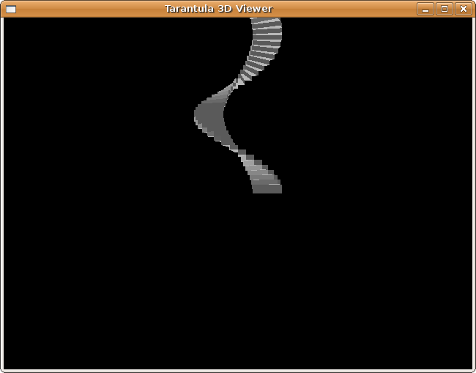

Since we have our stairs on screen, it seems that we are done now, but this is not the case. I will try to explain to you that we can do a much better job if we rewrite our show() function into a converter. To name a few reasons:

- Right now, we are using Spyder's previewer, but soon we will be moving to Blender. With show functions, we can only visualize objects in Blender. With converters, we can also edit them, which is what we want to do.
- We could implement another stairs that is very similar to this one (for example a version for advanced users, with more parameters). With converters, we don't have to maintain two separate show functions.
- Drawing the same object again and again is terribly slow for the computer; it can be done much faster with converters.

Rewriting our show function is very easy actually. First, move our visualization code out of the class definition:

Type MyBasicStairs3D {
...
}

def show(self):
...

Then, wrap the show() code in curly braces and add a conversion header to it. For now, we will convert to Chunk3DArray, which is a list of Chunk3Ds. We should also call our stairs something other than self, to prevent confusion. So, remove "def show(self)" and replace the whole function with this:

Define Chunk3DArray(MyBasicStairs3D s){
i = s.innerradius
o = s.outerradius
h = s.stepheight
rot = s.steprotation
vertices1= ((i,0,0),(o,0,0),(o,0,h), (i,0,h))
axis = AxisSystem()
axis.rotateZ(rot)
vertices2 = []
for v in vertices1: vertices2.append(Coordinate(v)*axis)
objlist = Chunk3DArray()
o = Chunk3D(vertices1, vertices2)
for n in range(s.steps):
objlist.append(Chunk3D(o)) #make a copy of o
o.axis.rotateZ(rot)
o.axis.origin.z += h
return objlist
}

Now, when we call .show() on the MyStairs object, Spyder will call our converter and call .show() on each of the objects in the Chunk3DArray.

C. Creating a more advanced stairs

Let's assume that our stairs is just a simpler version of a more advanced stairs, one that has more options. For example, a stairs of which the steps can lay partly on top of each other. We can create a new data model like this:

Type MyStairs3D:MyBasicStairs3D {
Float stepoverlap
validate {
assert stepoverlap >= 0
}
}

MyStairs3D now inherits from MyBasicStairs3D. Spyder-style inheritance means just that the whole definition of MyBasicStairs3D (everything in Type MyBasicStairs3D {..}) is included into MyStairs3D. Now, we change the converter like this:

Define Chunk3DArray(MyStairs3D s){ #CHANGED
i = s.innerradius
o = s.outerradius
h = s.stepheight
rot = s.steprotation
vertices1=((i,0,0),(o,0,0),(o,0,h), (i,0,h))
axis = AxisSystem()
rotsize = rot + s.stepoverlap/100 * rot #NEW
axis.rotateZ(rotsize) #CHANGED
vertices2 = []
for v in vertices1: vertices2.append(Coordinate(v)*axis)
objlist = Chunk3DArray()
o = Chunk3D(vertices1, vertices2)
for n in range(s.steps):
objlist.append(Chunk3D(o)) #make a copy of o
o.axis.rotateZ(rot)
o.axis.origin.z += h
return objlist
}

Now we have a separate stairs class which has implemented step overlap, for the advanced user. But can we still show a MyBasicStairs3D? Yes we can! Just add the following lines:

Define MyStairs3D(MyBasicStairs3D s) {
d = s.dict()
d["stepoverlap"] = 0
return MyStairs3D(d)
}

We made a dictionary copy of MyBasicStairs3D, added a stepoverlap of 0 and constructed a MyStairs3D out of it.
Now, calling show() on either a MyBasicStairs3D or a MyStairs3D will display a stairs. For MyStairs3D, the object will be converted into Chunk3DArray and then visualized. This is equivalent to MyStairs3D(...).convert(Chunk3DArray).show(). Our MyBasicStairs3D stairs defined in test.py will also show up just as before, although the conversion mechanism is now a two-step process: MyBasicStairs3D(...).show() is now equivalent to MyBasicStairs3D(...).convert(MyStairs3D).convert(Chunk3DArray).show(). You don't have to spell out any of this: once you have defined the converters, Spyder will take care of it for you.

D. Adding our stairs to Blender

We are already able to visualize our stairs in Blender. Since Spyder works with very basic show functions which are called through conversion, replacing those is all you have to do to target a different platform. This is done using the BLENDER switch. We can also already save our stairs objects in web files and import them in Blender.
However, Blender knows very little about our object and it cannot be edited inside Blender. Here I will explain the steps that are necessary to make a Spyder object editable in Blender.

First, we have to specify that MyStairs3D is a 3D object. This is done by adding a method to the MyStairs3D class:

Type MyStairs3D:MyBasicStairs3D {
Float stepoverlap
validate {
assert stepoverlap >= 0
}
#NEW:
@staticmethod
def three_dimensional(): return True
}

Then, we have to specify some boundaries for the Blender interface. This is done in the form block. First, the keyword BLENDER indicates that a Blender interface must be generated. Second, every parameter must have a default value. Third, every parameter must have bounds: either absolute minimum and maximum values, or an initial range that can be narrowed and broadened with >< and <>.

Type MyStairs3D:MyBasicStairs3D {
Float stepoverlap
validate {
assert stepoverlap >= 0
}
@staticmethod
def three_dimensional(): return True
#NEW:
form {
BLENDER
DEFAULT steps 10
RANGE steps 10
DEFAULT innerradius 3
RANGE innerradius 3
DEFAULT outerradius 5
RANGE outerradius 5
DEFAULT stepheight 1
RANGE stepheight 1
DEFAULT steprotation 10
RANGE steprotation 10
DEFAULT stepoverlap 0
MIN stepoverlap 0
MAX stepoverlap 100
}
}

Save everything and start Blender. Select Object=>Scripts=>Create/Edit Spyder object, and if you did everything right, MyStairs3D is now in the list of objects. Congratulations, you have just created a Blender plugin!

E. The finishing touch

We have come a long way. We have created a stairs that can be created, edited, saved, loaded, copied and scripted, in Python and in Blender. There are just a few more things that need to be done to make it perfect. First of all, the Blender visualization is horribly slow. For example, in Blender, expand the range of steps a few times and set it to 100-200, then press Preview. Unless your computer is a lot faster than mine, it will take 10 or more seconds to build a stairs. That's because each step is generated and sent to Blender seperately, even though they are all identical. It would be much faster to generate only one step and make a lot of linked copies, each of them transformed by a matrix. Spyder has a handy class for that called MultiInstance3D. It consists of two parameters: instances, which is a AxisSystemArray, and object, which is an ObjectList3D. ObjectList3D is a list of Spyder objects that can be of any type, provided that they are all 3D, i.e. they have a method three_dimensional() that returns True. MyStairs3D and Chunk3D are both 3D objects, so both of them could be contained in an ObjectList3D. In our case, the list will contain only a single object, the Chunk3D that is the first step we generate. Our conversion function can then be rewritten to return a MultiInstance3D, like this:

Define MultiInstance3D(MyStairs3D s){ #CHANGED
i = s.innerradius
o = s.outerradius
h = s.stepheight
rot = s.steprotation
vertices1=((i,0,0),(o,0,0),(o,0,h), (i,0,h))
axis = AxisSystem()
rotsize = rot + s.stepoverlap/100 * rot
axis.rotateZ(rotsize)
vertices2 = []
for v in vertices1: vertices2.append(Coordinate(v)*axis)
# objlist = Chunk3DArray() #DELETED
o = Chunk3D(vertices1, vertices2)
object = ObjectList3D(o) #NEW
a = AxisSystem() #NEW
instances = [] #NEW
for n in range(s.steps):
instances.append(AxisSystem(a)) #CHANGED
a.rotateZ(rot) #CHANGED
a.origin.z += h #CHANGED
mi = MultiInstance3D(object=object, instances=instances) #NEW
return mi #CHANGED
}

As a test, run test.py again. Even when you put steps to 1000, it will render within a few seconds in the Spyder previewer. In Blender, it is not that lightning-fast, but 1000 steps can still be rendered in 10 seconds or so (remember to restart Blender after you changed mystairs.spy). Almost a factor 10 speed-up!

There is only one thing left: our object is not yet movable. In Blender, during editing, when you drag the object to another place and then press Preview, the object will move back to the center. The same goes for rotation. This is because our stairs does not have a rotation/translation matrix. Let's add one:

Type MyStairs3D:MyBasicStairs3D {
Float stepoverlap
AxisSystem axis = AxisSystem() #NEW
validate {
assert stepoverlap >= 0
}
@staticmethod
def three_dimensional(): return True
form {
...
}
}

Since we gave it a default value, our matrix is not a required parameter, and our test.py script and Blender interface still work. But to make it have any effect, we must incorporate it into our converter. We could apply the matrix to each of the instances, and it would visualize correctly, but this would prevent our matrix from being responsive to dragging in Blender. The correct way is to create an ObjectGroup3D, which consists of an ObjectList3D called group and a single matrix called axis. The group variable will contain only a single object, which is our MultiInstance3D. The axis is the extra parameter that we just specified. Just edit the converter like this:

Define ObjectGroup3D(MyStairs3D s){ #CHANGED
...
return ObjectGroup3D(group=mi, axis=s.axis) #CHANGED
}
And all we have to do now is to tell Blender which is our matrix variable:

Type MyStairs3D:MyBasicStairs3D {
...
form {
BLENDER
MATRIX axis #NEW
...
}
}

Save everything, restart Blender, and start again the stairs plugin. Move the stairs around, and you will see that it stays there after hitting Preview. You can even see the axis origin values change. We are finished!

